Launch an EC2 instance Linux along with a web server. Then, create an EBS volume of 5 GB, attach it to an EC2 machine Linux, and take a snapshot. Finally, create an EBS volume using the taken snapshot.
Objective :
The objective of this project is to launch a Linux EC2 instance on AWS and configure it with a web server for hosting web content. Additionally, the project aims to demonstrate EBS volume management by creating a 5 GB EBS volume, attaching it to the Linux instance, and taking a snapshot for backup and recovery purposes.
Step 1: Launch EC2 Instances
- Navigate to EC2 → Instances → click Launch Instance
- AMI: Ubuntu Server 24.04 LTS (HVM)
- Instance Type: t2.micro
- Key Pair: Create key pair
- Network Settings: Default VPC and subnet
- Security Groups :
  - Allow SSH (port 22)
  - Allow HTTP & HTTPS (80 & 443)
- Storage : 8 GB default
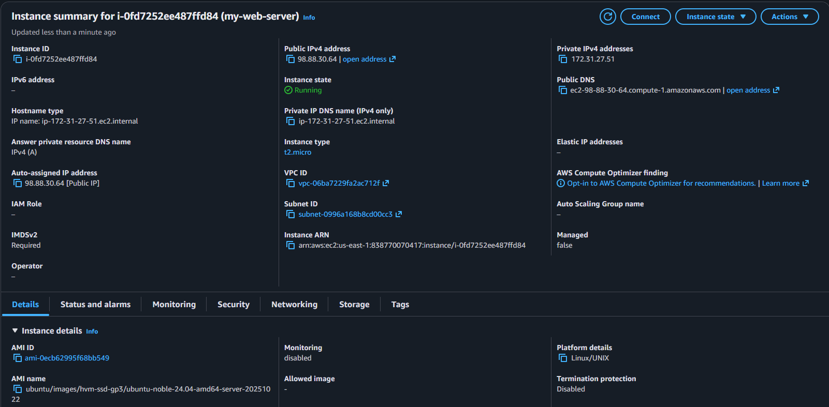

Step 2: Connect to Instances
- Connect with putty using key pair
- 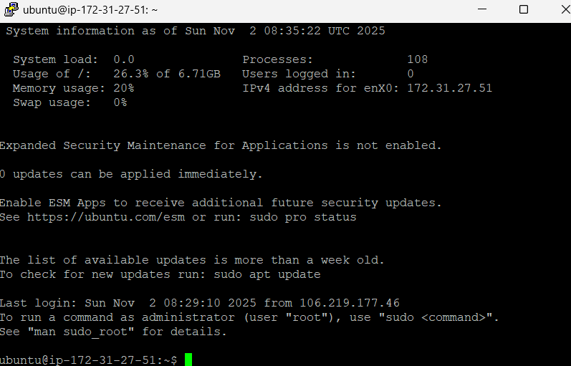
Step 3: Install Apache Web Servers
- Commands used :
  - sudo apt update -y
  - sudo apt install apache2 -y
  - sudo systemctl start apache2
  - sudo systemctl enable apache2
  - sudo systemctl status apache2 (to check apache is installed or not)
- Create a webpage :
  - sudo nano /var/www/html/index.html
  - Write html content
  - sudo chmod 644 /var/www/html/index.html
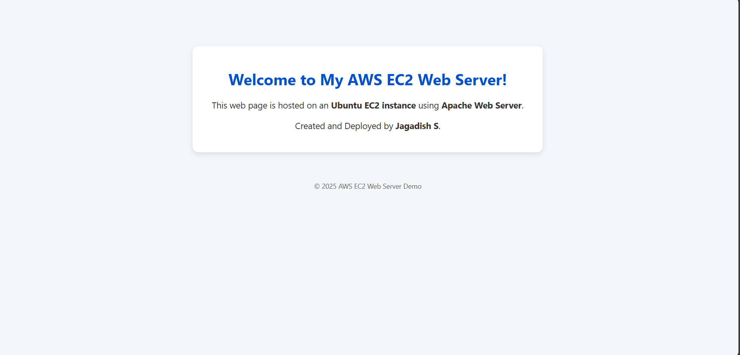
Step 4: Create and attach a 5 GB EBS Volume
- Create EBS Volume
- Navigate to EC2 → Elastic Block Store → Volumes → Create Volume
- Size: 5 GB
- Availability Zone: Same as EC2 instance (us-east-1a)
- Click Create Volume
- Attach to Instance
- Select the volume → Actions → Attach Volume
- Choose your Linux or Windows instance.

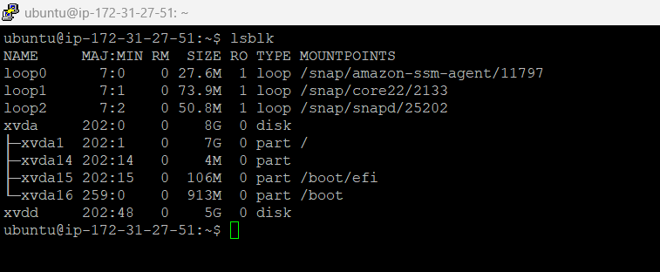

Step 6: Create Snapshot
- Navigate to EC2 → Volumes → Select your volume → Actions → Create Snapshot
- Click Create Snapshot
Step 7: Create New EBS Volume from Snapshot
- Go to Snapshots → Select snapshot → Actions → Create Volume from Snapshot
- Choose the same Availability Zone as EC2 instance.
- Click Create Volume.
